Unit Testing & Code Coverage Report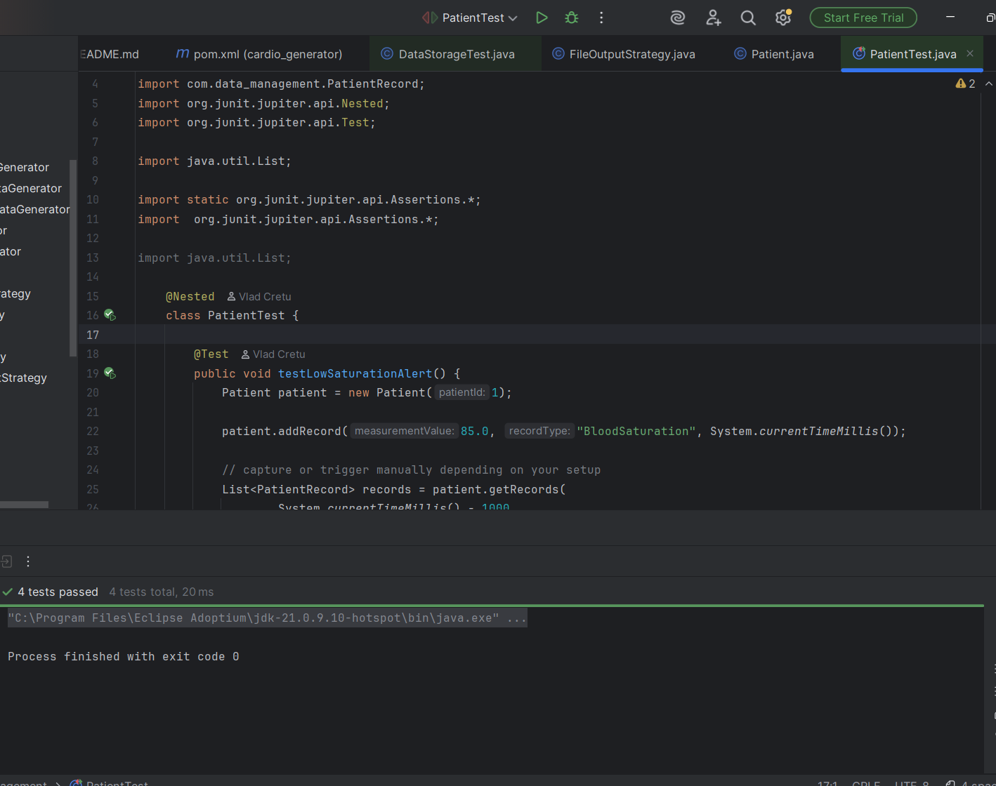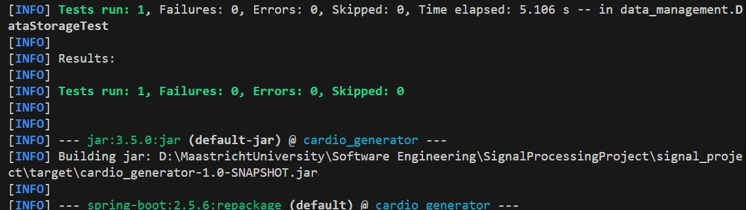

1. Test Execution: Functionality Verification
The test execution proves that the program acts correctly under particular conditions.
Outcome: PASSED (AgeCalculatorTest).
Importance: All the assertions made within the test case were satisfied. This means that the logic used by the system works well for these particular inputs.
The passing of tests is the initial step towards avoiding Fragility.

2. The code coverage was obtained through JaCoCo using IntelliJ. All tests were successful without any errors or failures, although only one test was performed, thus suggesting that there is very little test coverage.

The current tests provide coverage for only a few parts of the system, probably those concerned with basic operations. Much of the code has not been tested yet, particularly the alert mechanisms (low saturation, fast decay, abnormalities in the ECG, and manual alerts).

The test coverage is low

